**DEEP LEARNING REPORT – LAB #1**

**Introduction:**

This Assignment is used to analyze a dataset using Logistic Regression technique. Logistic regression is a regression model where the dependent variable will have more than two categories.

**Objectives:**

To have a dataset (MNIST) find the accuracy of the test batch by using Logistic Regression approach

**Approaches/Methods:**

Using TensorFlow library to generate the accuracy and using TensorBoard to visualize the approach as graphs with additional options

**Workflow:** 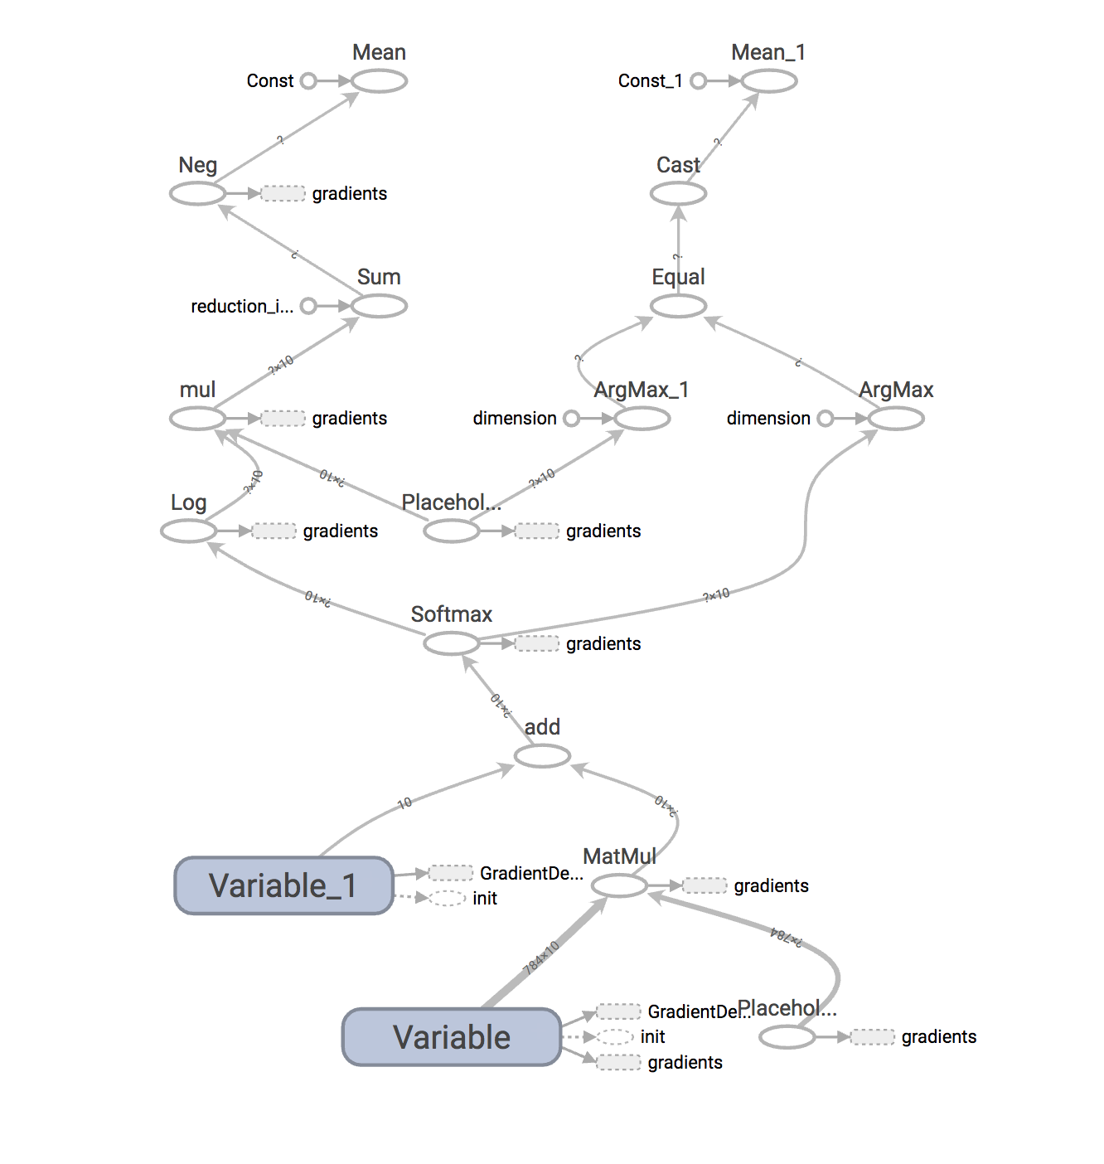

**Datasets:**

MNIST dataset which is a collection of handwritten digits which has the training batch around 60K and test batch around 10K

**Parameters:**

Learning Rate = 0.001  
Epochs = 23  
Batch Size = 80  
Display Step = 2

**Evaluation & Discussion:**

Epoch: 0001 cost= 1.183629289

Epoch: 0002 cost= 0.665250208

Epoch: 0003 cost= 0.552817128

Epoch: 0004 cost= 0.498586386

Epoch: 0005 cost= 0.465509497

Epoch: 0006 cost= 0.442541073

Epoch: 0007 cost= 0.425531410

Epoch: 0008 cost= 0.412142993

Epoch: 0009 cost= 0.401411695

Epoch: 0010 cost= 0.392390823

Epoch: 0011 cost= 0.384803265

Epoch: 0012 cost= 0.378213381

Epoch: 0013 cost= 0.372421877

Epoch: 0014 cost= 0.367295480

Epoch: 0015 cost= 0.362746554

Epoch: 0016 cost= 0.358593896

Epoch: 0017 cost= 0.354905972

Epoch: 0018 cost= 0.351454932

Epoch: 0019 cost= 0.348353139

Epoch: 0020 cost= 0.345345943

Epoch: 0021 cost= 0.342748604

Epoch: 0022 cost= 0.340254951

Epoch: 0023 cost= 0.337938607

Accuracy: 0.9637

**Conclusion:**

To conclude, the MNIST dataset is used to test data and find accuracy using Logitic Regression